**Mineral Processing Technology – Image Analytics**

In the field of Mineral Processing Technology, size analysis of the various particles of an extracted sample is of importance in determining the quality of minerals, entropy values and in establishing the degree of liberation of the values from the gangue at various particle sizes.

In this problem statement, candidate is required to analyze the mineral particles in the input folder and calculate the following -

1. The smallest circle that just encapsulates the particle (the circle has to be generated on the image).

Example –



2. Total surface area of the particle (in pixels) (Has to be generated on the image)

Example –

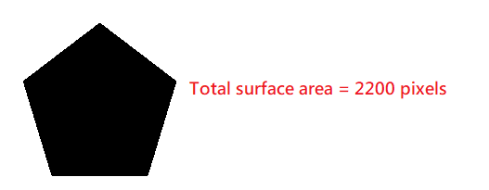

3. The major axis (longest axis) in the particle that lies entirely inside the particle (in pixels) (Has to be generated on the image)

Example –



4. Total perimeter of the particle (in pixels) (Has to be generated on the image)

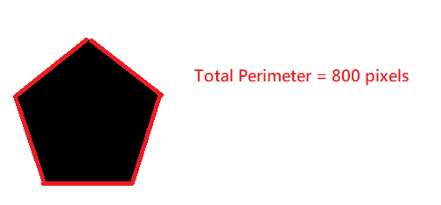

5. Centroid of the particle (Has to be generated on the image)

